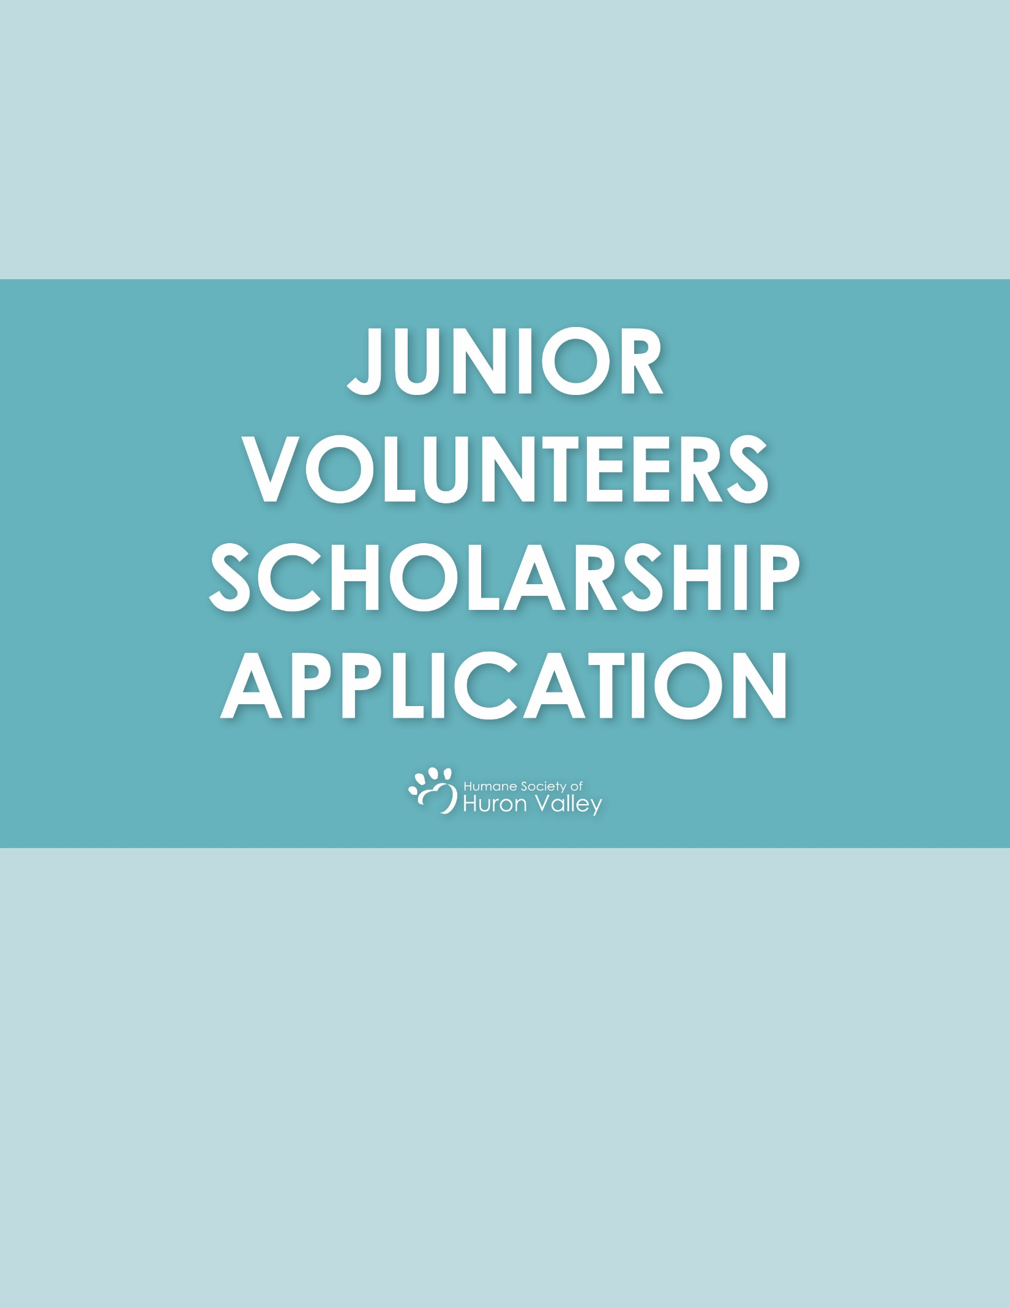
Thank you for your interest in applying for our Junior Volunteers scholarship. All scholarship applications are due by 4:00 p.m. on Friday, January 31st, 2020. All sections of the application must be completed in order for your application to be considered. Acceptance and regret letters will be emailed out to all applicants by Wednesday, February 5th, 2020. Applicants do not need to do the general registration process as extra spaces are saved for scholarship applicants. The Junior Volunteers scholarship application is limited to students in households that demonstrate financial need.

Participant’s Name_______________________________________________________________________________

Address_______________________________________City__________________________State______Zip _______

Phone___________________________________________________________________________________________

Age_______________ T-shirt size (in adult sizes) ______________Date of Birth:_________________________

Email_____________________________________________________________________________________________

Parent/Guardian Name___________________________________________________________________________

Parent/Guardian Phone Number__________________________________________________________________

Participant’s School District________________________________________________________________________

Does the participant have any special education needs? Yes No
If yes, please explain:

Does the participant have any allergies or medical needs? Yes No
If yes, please explain:

Which session of our JV program are you interested in attending? (Please check all that apply. It is recommended to choose at least two.) Please see the website for exact dates.

____March M/W session
____March T/Th session

____ April M/W session
_____April T/Th session
I understand that the Junior Volunteers scholarship is designed for families who demonstrate financial need. I understand that the youth participant is expected to display a 100% attendance rate for the six sessions of our Junior Volunteers program and volunteer for 4-6 hours a month thereafter. I have read and agree to the terms listed in the Junior Volunteers waiver form (attached-please read carefully).

Name_______________________________________________ Signature__________________________________

I am the youth’s: Parent Teacher Social worker Other

ESSAY PORTION
All essays must be written by and in the words of the applicant or the application will not be considered. In the space provided below, please tell us why you are interested in being a Junior Volunteer at the Humane Society of Huron Valley. Be sure to include information about:

• Your experience with animals
• Any future animal welfare career goals
• What personal qualities you have that would make you an outstanding Junior Volunteer
• Why you feel that you are an excellent applicant for the Junior Volunteers program

Waiver and Consent Form- PLEASE READ CAREFULLY
• The Junior Volunteers program is designed for families in financial need. By applying, you are confirming that your child would not otherwise be able to participate in the program.

• JV Scholarships are awarded in the amount of $185, which is the registration fee for the program. Awarded applicants will not receive funds but will be registered in the program free of cost. Scholarship applicants should not complete the online registration for the program and need only to complete this form to be considered.

• Participants will come into contact with soy, dairy, nut and wheat products.

• All participants are required to wear closed toed shoes for their safety. Participants who arrive with open toed shoes will not be allowed to participate.

• All Humane Society of Huron Valley participants will interact with animals. Animals may include (but are not limited to) dogs, cats, rabbits, guinea pigs, cows, horses, goats, ducks, lizards, ferrets. HSHV cannot discriminate which animals participants interact with during the program. Requests for participants to not engage with certain animals cannot be honored.

• Participants should not arrive more than 10 minutes prior to their scheduled start time. All participants who do not drive themselves are to be picked up promptly at the conclusion of their program. HSHV does not have the staff to supervise participants after session hours. In case of late pickup, emergency contacts will immediately be contacted. Participants will not be released to any person who is not listed under the emergency contacts. Proper picture ID will be required for anyone picking up a participant.

• Participants who are seeking to obtain hours of community service will be responsible for obtaining the required form and bringing them to the sessions. Forms will be signed with documented hours upon the completion of all six sessions. Court ordered community service needs to be disclosed and discussed with our Humane Educator prior to registration. Not all court ordered offenses will be accepted in our Junior Volunteers program.

• Participants who bring cell phones with them to the Humane Society of Huron Valley should expect to use their phones only to contact parents in case of an emergency. Calling or texting during activities will not be permitted. Participants who are unable to abide by this policy will be dismissed from the program.

• While allowing time with shelter animals is an important part of the J.V. program, time with our adoptable animals is very limited and closely monitored. Participants will have opportunities to interact with a variety of animals, but should not expect to spend significant amounts of time with animals waiting for adoption.

• Individual make up sessions are not available for any reason. If a participant misses a session, he/she will stop the program there. Scholarships are not transferrable to another session. Junior Volunteers will not be permitted to volunteer at HSHV until all six sessions have been completed.

• All Humane Society of Huron Valley J.V. Club participants are expected to display safe, respectful and appropriate behavior at all times towards staff, volunteers, guests, other participants and animals. Behavior guidelines and expectations will be reviewed with participants on the first day of the J.V. Club. If a participant is consistently unable to abide by these expectations and guidelines, he/she may be dismissed from the J.V. Club for the day or for the remainder of the session. HSHV reserves the right to deny participation to any participant who exhibits unsafe behavior with staff, participants or animals at any time. Refunds and pro-ration of scholarships are not available if a participant is dismissed from the program or for any other reason. Scholarships are not transferrable to other sessions.

• All participants must have a parent or guardian sign the “Minor Waiver” form in order to participate. This form will be mailed to all participants 7-10 days before the start of the first session. Any participant who does not have a signed waiver at the start of the first session will not be able to participate in the program.

